XXXVI Polish Malacological Seminar
Wisła, 7-9 May 2020
(the Silesian Beskids, Poland)

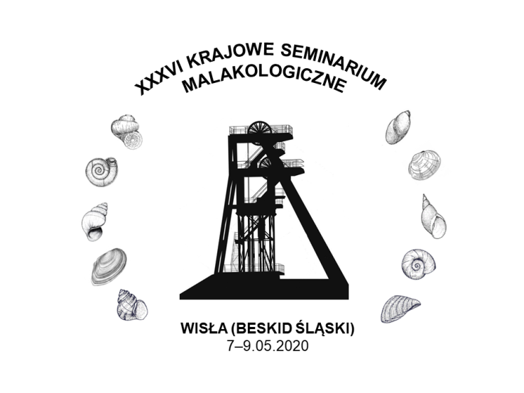

REGISTRATION FORM
(Participants of the Seminar are asked to fill in two tables and return the registration form to the address: seminarium.malakologiczne@us.edu.pl)

Accommodation and meals in the “Hotel pod Jedlami”
(please, cross the appropriate boxes)

 | Breakfast (buffet)  included in the price of the accommodation | Dinner (served)  40 PLN | Supper (standard)  35 PLN | Accommodation
6.05.2020
(Wednesday)
7.05.2020 (Thursday) |  |  | „wiślański grill”
8.05.2020
(Friday)
9.05.2020
(Saturday)

Surname
Name
Academic degree/title
Ph.D. student
Member of the Association of Polish Malacologists/Honorary Member of the Association Polish Malacologists

Institution

Address of the Institution

E-mail
Lecture/short lecture/poster
(size 70 x 100 cm)
Title/Author/Authors*

Details for the invoice for the accommodation and meals

Vegetarian diet/gluten free diet/other
I declare participation in the "Little Beskid Loop" trip

Reservation of double room: STANDARD, ECONOMY, DELUXE and preferred roommate in a double room

Reservation of a double room for 1 person in a room

* in the title of the co-authored oral presentation /short oral presentation/poster, please mark the person who will give the presentation (bold and underlined font)

